Declaration of Independence Assignment

Directions:
- Read and annotate paragraphs 1-3, 27, and 33. Annotate in comment boxes and take notes ONLY on main ideas and key details of those paragraphs.
- Answer all of the questions in the margins of the text. Answer them in comment boxes. For questions that require you to annotate and analyze language, here is an example:
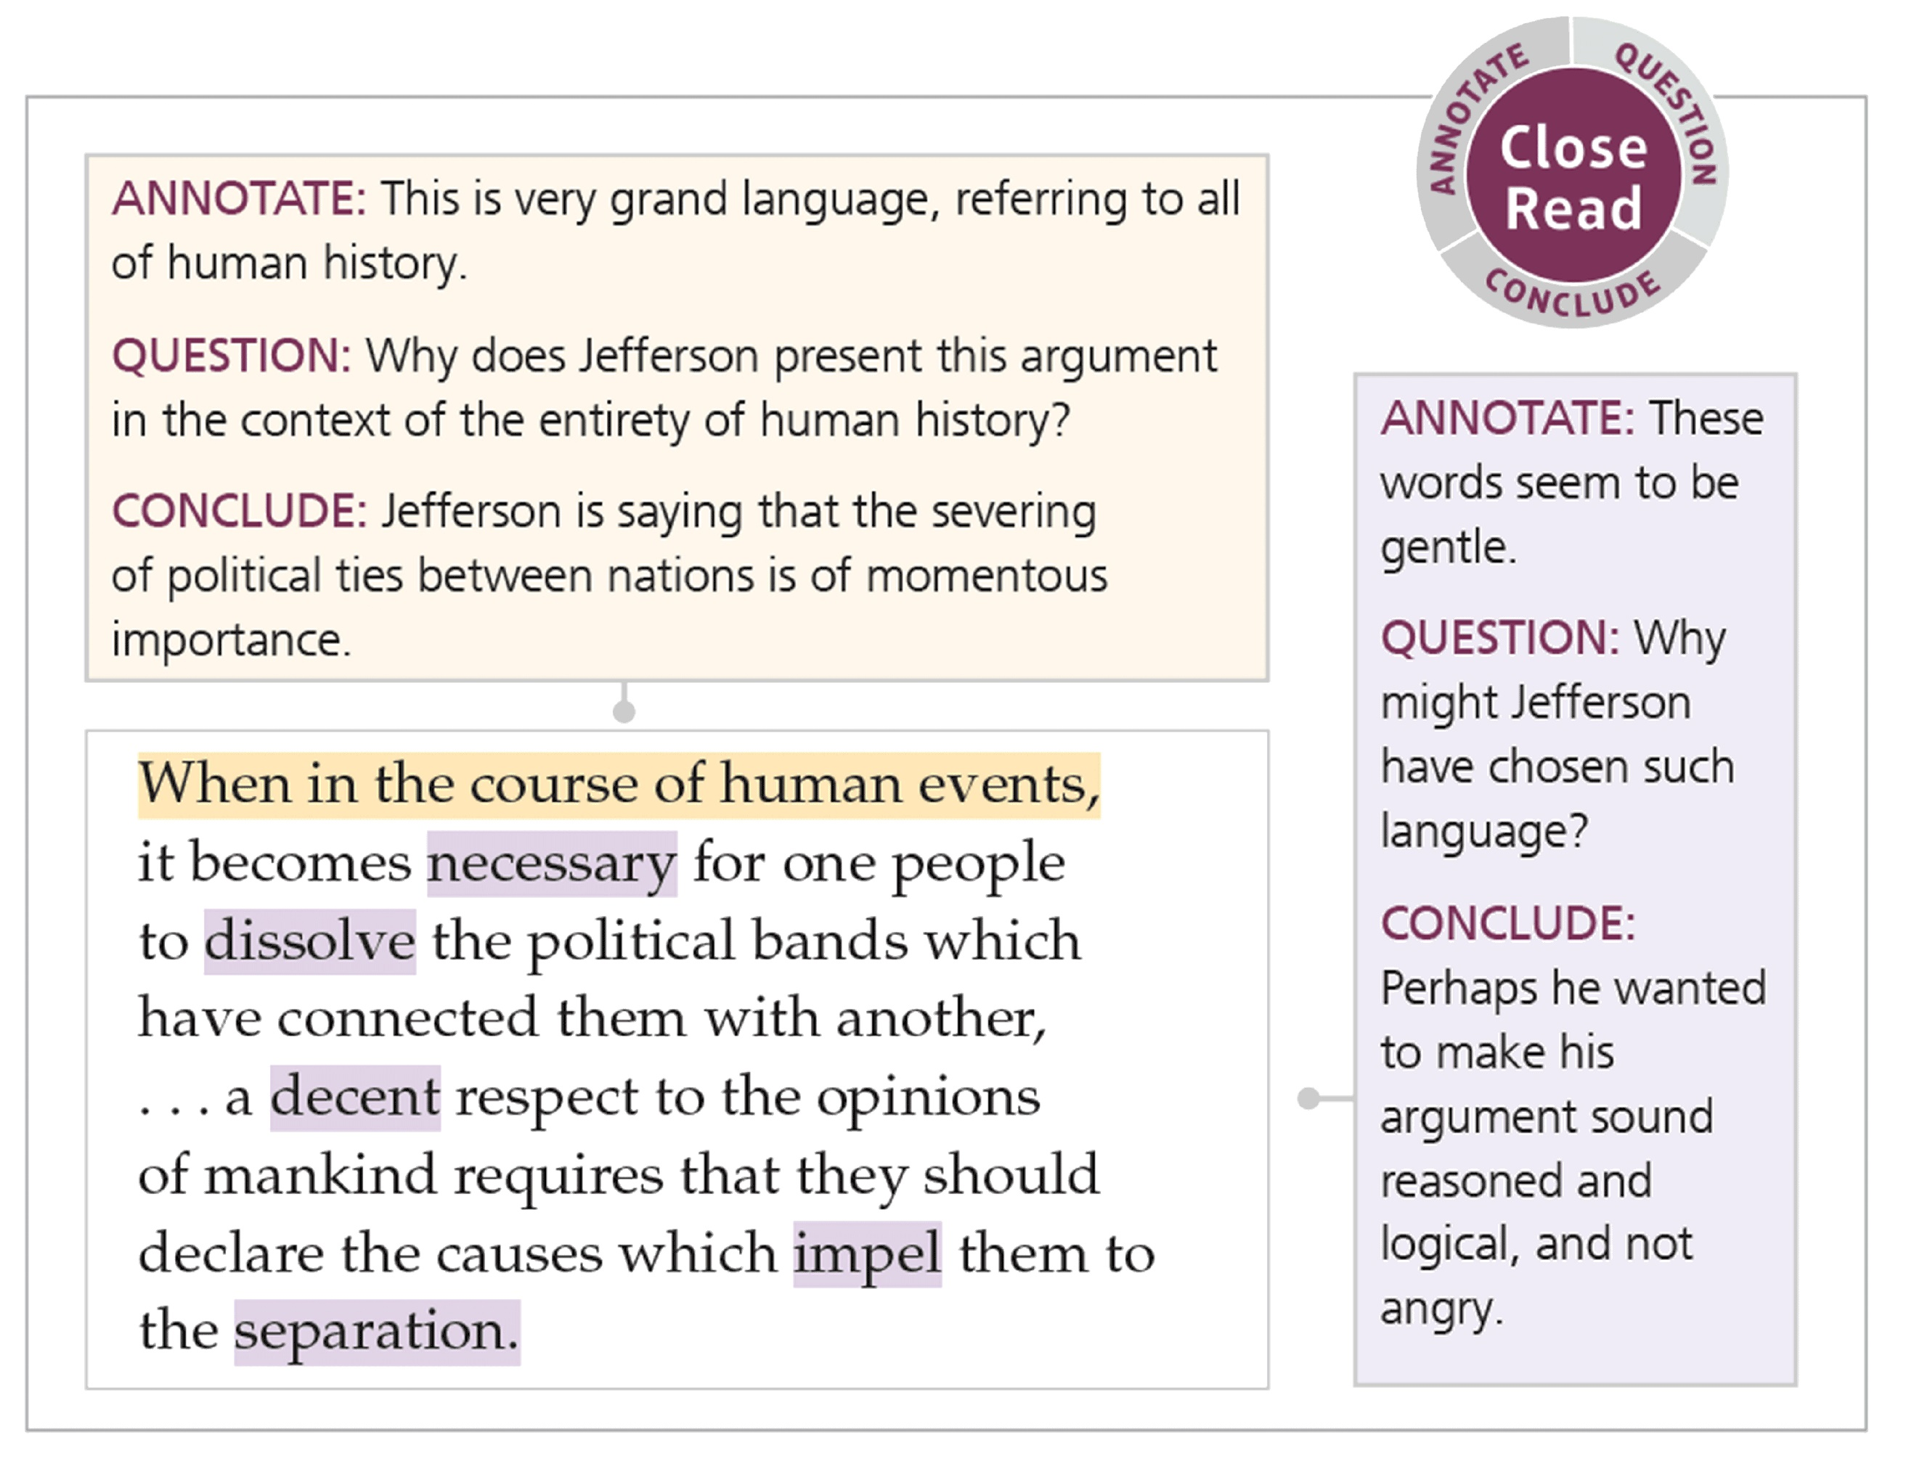
- Choose at least 5 vocabulary words from the passage that are new/unfamiliar to you and complete the Vocabulary Four Square charts for all 5 terms. Look at my example. These charts can be found on the page after the text.
- Complete a set of Level Questions AND a SOAPSTone analysis. The area to complete these is on the page after the Four Square charts.

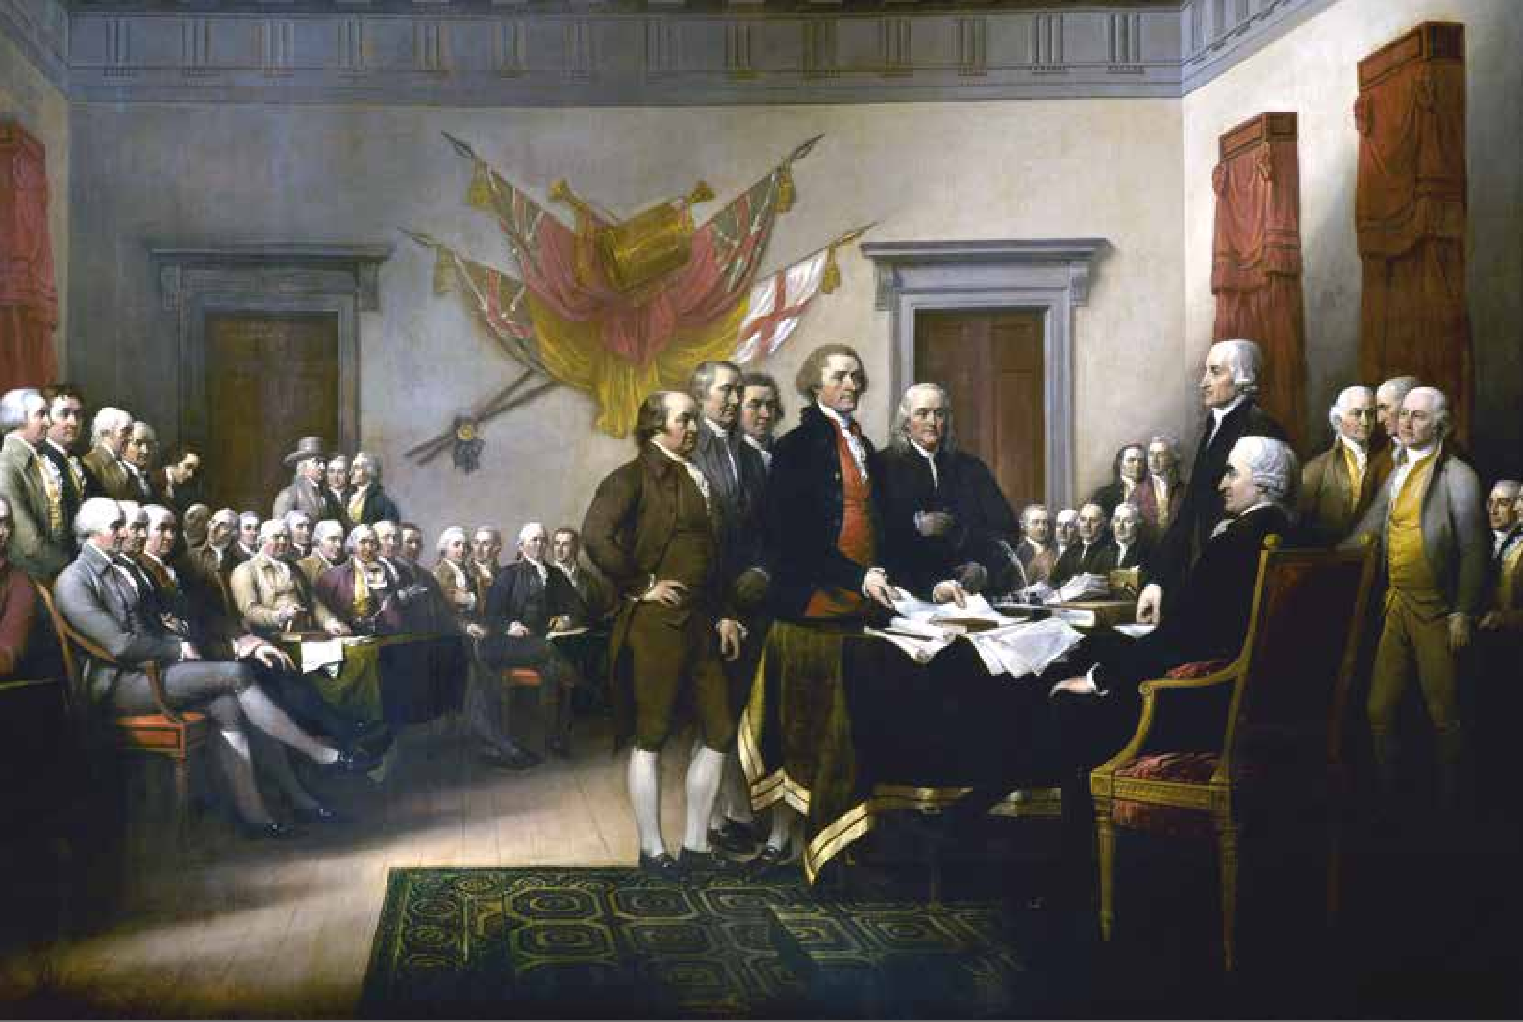
Thomas Jefferson

ANCHOR TEXT | FOUNDATIONAL DOCUMENT
ANCHOR TEXT | FOUNDATIONAL DOCUMENT

of Independence
Declaration

Thomas Jefferson

BACKGROUND
The Continental Congress was formed in 1774 by the American colonies to coordinate resistance to British laws considered by most colonists to be unfair. In the summer of 1776, after about a year of war against Britain, representatives met to consider an official break with Britain.

IN CONGRESS, July 4, 1776.
1. What rhetorical appeal(s) does Jefferson use here in the beginning? Why? For what purpose/effect?

2. Based on the diction (word choice) and syntax (sentence length/structures) used, how would you describe Jefferson’s writing style/voice?

NOTES
unalienable (uhn AYL yuh nuh buhl) adj. impossible to take away or give up
1 The unanimous declaration of the thirteen united states of America,
2 When in the course of human events, it becomes necessary for one people to dissolve the political bands which have connected them with another, and to assume among the powers of the earth, the separate and equal station to which the laws of nature and
3. When this highlighted sentence was written, do you think Jefferson and the founding fathers intended this idea to one day include all people, not just white men who owned property? Why or why not?
of nature’s God entitle them, a decent respect to the opinions of mankind requires that they should declare the causes which impel them to the separation.
3 We hold these truths to be self-evident: that all men are created equal; that they are endowed by their creator with certain unalienable rights, that among these are life, liberty and the pursuit of happiness; that to secure these rights, governments are
instituted among men, deriving their just powers from the consent

of the governed; that whenever any form of government becomes destructive of these ends, it is the right of the people to alter or to abolish it, and to institute new government, laying its foundation on such principles and organizing its powers in such form, as to them shall seem most likely to effect their safety and happiness. Prudence, indeed, will dictate that governments long established should
4. What does this mean that governments should not be changed for “light” reasons AND what would we consider a strong enough reason “to alter or to abolish” our form of government today?
NOTES
5. CLOSE READ
ANNOTATE: Mark words in the last two sentences of paragraph 3 that seem
especially strong or extreme.
QUESTION: Why would Jefferson employ such strong language in these two sentences?
CONCLUDE: What effect might his language choices here have had on the American colonists? The British officials?
constrains (kuhn STRAYNZ) v.
requires or forces
tyranny (TIHR uh nee) n.
oppressive power
assent (uh SEHNT) n. approval or agreement
not be changed for light and transient causes; and accordingly all experience hath shown, that mankind are more disposed to suffer, while evils are sufferable, than to right themselves by abolishing the forms to which they are accustomed. But when a long train of
abuses and usurpations,1 pursuing invariably the same object evinces a design to reduce them under absolute despotism, it is their right,
it is their duty, to throw off such government, and to provide new guards for their future security. Such has been the patient sufferance of these colonies; and such is now the necessity which constrains them to alter their former systems of government. The history of
the present King of Great Britain is a history of repeated injuries and usurpations,1 all having in direct object the establishment of an absolute tyranny over these states. To prove this, let facts be submitted to a candid world.
4 He has refused his assent to laws the most wholesome and necessary for the public good.
5 He has forbidden his governors to pass laws of immediate and pressing importance, unless suspended in their operation till his assent should be obtained; and when so suspended, he has utterly neglected to attend to them.
6 He has refused to pass other laws for the accommodation of large districts of people, unless those people would relinquish the right of representation in the legislature, a right inestimable to them and formidable to tyrants only.
7 He has called together legislative bodies at places unusual, uncomfortable, and distant from the depository of their public records, for the sole purpose of fatiguing them into compliance with his measures.
Copyright © Savvas Learning Company LLC. All Rights Reserved.
8 He has dissolved representative houses repeatedly, for opposing with manly firmness his invasions on the rights of the people.
9 He has refused for a long time, after such dissolutions, to cause others to be elected, whereby the legislative powers, incapable of annihilation, have returned to the people at large for their exercise, the state remaining in the mean time exposed to all the dangers of invasion from without, and convulsions within.
10 He has endeavored to prevent the population of these states; for that purpose obstructing the laws for naturalization of foreigners, refusing to pass others to encourage their migrations hither, and raising the conditions of new appropriations of lands.

- usurpations (yoo zuhr PAY shuhnz) n. unlawful or violent seizures of power or possessions.

11 He has obstructed the administration of justice, by refusing his assent to laws for establishing judiciary powers.
NOTES
6. CLOSE READ
ANNOTATE: Mark the verbs in paragraph 27 that describe what the king has done to the colonists.
QUESTION: Why do you think Jefferson chose these verbs?
CONCLUDE: What is the effect of this language?
12 He has made judges dependent on his will alone, for the tenure of their offices, and the amount and payment of their salaries.
13 He has erected a multitude of new offices, and sent hither swarms of officers to harass our people, and eat out their substance.
14 He has kept among us in times of peace standing armies without the consent of our legislatures.
15 He has affected to render the military independent of, and superior to, the civil power.
16 He has combined with others to subject us to a jurisdiction foreign to our constitution, and unacknowledged by our laws; giving his assent to their acts of pretended legislation:
17 For quartering2 large bodies of armed troops among us:
18 For protecting them, by a mock trial, from punishment for any murders which they should commit on the inhabitants of these states:
19 For cutting off our trade with all parts of the world:
20 For imposing taxes on us without our consent:
21 For depriving us in many cases, of the benefits of trial by jury:
22 For transporting us beyond seas to be tried for pretended offenses:
23 For abolishing the free system of English laws in a neighboring province, establishing therein an arbitrary government, and enlarging its boundaries so as to render it at once an example and fit instrument for introducing the same absolute rule into these colonies:
24 For taking away our charters, abolishing our most valuable laws, and altering fundamentally the forms of our governments:
25 For suspending our own legislatures, and declaring themselves invested with power to legislate for us in all cases whatsoever.
26 He has abdicated government here, by declaring us out of his protection and waging war against us.
27 He has plundered our seas, ravaged our coasts, burned our towns, and destroyed the lives of our people.
28 He is at this time transporting large armies of foreign mercenaries to complete the works of death, desolation and tyranny, already begun with circumstances of cruelty and perfidy scarcely paralleled in the most barbarous ages, and totally unworthy the head of a civilized nation.
Copyright © Savvas Learning Company LLC. All Rights Reserved.
29 He has constrained our fellow citizens taken captive on the high seas to bear arms against their country, to become the executioners of their friends and brethren, or to fall themselves by their hands.
30 He has excited domestic insurrections amongst us, and has endeavored to bring on the inhabitants of our frontiers, the merciless Indian savages, whose known rule of warfare, is an undistinguished destruction of all ages, sexes, and conditions.
31 In every stage of these oppressions we have petitioned for redress in the most humble terms: Our repeated petitions have been

- quartering v. housing.

answered only by repeated injury. A prince whose character is thus marked by every act which may define a tyrant, is unfit to be the ruler of a free people.
NOTES
acquiesce (ak wee EHS) v. accept something reluctantly but without protest
rectitude (REHK tuh tood) n. morally correct behavior or thinking; uprightness
32 Nor have we been wanting in attentions to our British brethren. We have warned them from time to time of attempts by their legislature to extend an unwarrantable jurisdiction over us. We have reminded them of the circumstances of our emigration and settlement here. We have appealed to their native justice and magnanimity, and we have conjured them by the ties of our common kindred to disavow these usurpations, which, would inevitably interrupt our connections and correspondence. They too have been deaf to the voice of justice and of consanguinity.3 We must, therefore, acquiesce in the necessity, which denounces our separation, and hold them, as we hold the rest of mankind, enemies in war, in peace friends.
33 We, therefore, the representatives of the United States of America, in General Congress assembled appealing to the Supreme Judge of the world for the rectitude of our intentions, do in the name and by authority of the good people of these colonies, solemnly publish and declare that these united colonies are and of right ought to be free and independent states; that they are absolved from all allegiance
to the British Crown, and that all political connection between them and the state of Great Britain is and ought to be totally dissolved; and that as free and independent states, they have full power to levy war, conclude peace, contract alliances, establish commerce, and to do all other acts and things which independent states may of right do. And for the support of this declaration, with a firm reliance on the protection of divine providence, we mutually pledge to each other our lives, our fortunes and our sacred honor.
7. What rhetorical appeal(s) does Jefferson use here at the very end? Why? For what purpose/effect?

- consanguinity (kon sang GWIHN uh tee) n. blood relationship.

Four-Square Vocabulary Charts

EXAMPLE
Word:  Unalienable | Example sentence:  Because freedom of speech is in unalienable right, all citizens are free to express themselves however they want.
Definition (with part of speech):  adj. impossible to take away or give up | Related word with a definition:  Alienate - cause (someone) to feel isolated or estranged.

Word: | Example sentence:
Definition (with part of speech): | Related word with a definition:

Word: | Example sentence:
Definition (with part of speech): | Related word with a definition:

Word: | Example sentence:
Definition (with part of speech): | Related word with a definition:

Word: | Example sentence:
Definition (with part of speech): | Related word with a definition:

Word: | Example sentence:
Definition (with part of speech): | Related word with a definition:

Level Questions and SOAPSTone

Level 1:

Level 2:

Level 3:

Speaker (identity of speaker(s) and how they are/how they represent themselves)

Occasion (time and place/immediate reason for this text and the larger occasion)

Audience (individual or group)

Purpose (argument/reason for the text AND what the speaker wants to accomplish)

Subject (list of general topics and ideas)

Tone (attitudes a writer takes toward a subject or audience & what effect it has)

Technique (any literary/rhetorical devices & what effect they have)

