ACCOUNTING MONOPOLY Reference Sheet
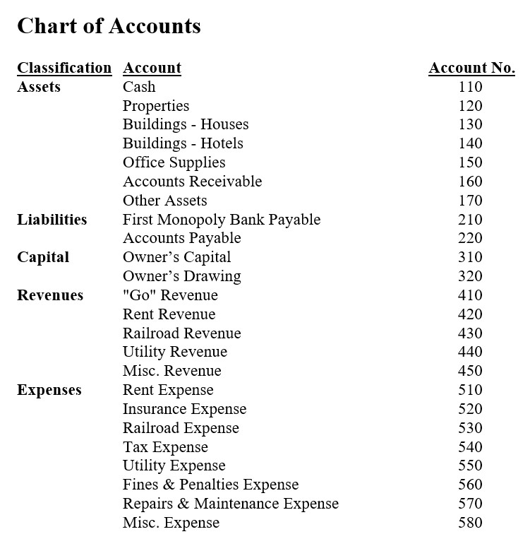
Example Transactions
Transaction | Debit | Credit
Purchased Park Place property, $400 | Properties | Cash
Purchased house for Park Place, $125 | Buildings - Houses | Cash
Rec'd cash for rent from Illinois Avenue, $50 | Cash | Rent Revenue
Paid cash to Brayden for R&R Railroad, $100 | Railroad Expense | Cash
Received cash bonus for good work, $300 | Cash | Misc. Revenue
Received loan from the bank, $500 | Cash | First Monopoly Bank Payable
Paid $150 for income tax | Tax Expense | Cash
Owner invests $1500 in business | Cash | Owner's Capital
Purchased Electric Company for $150 | Properties | Cash
Passed "Go" and collected $200 in revenue | Cash | "Go" Revenue
Collected $450 revenue from Free Parking | Cash | Misc. Revenue
Paid $100 for Office Supplies | Office Supplies | Cash
Paid $50 for Insurance | Insurance Expense | Cash

